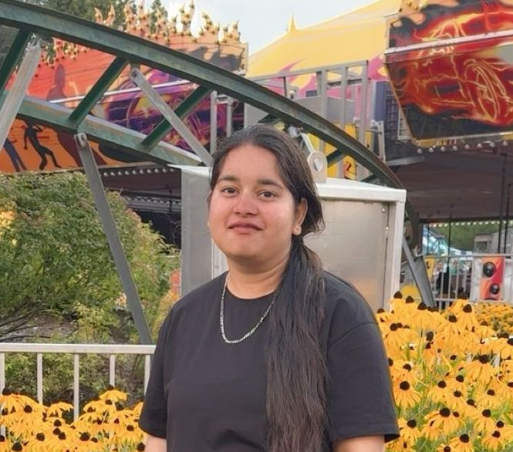
Name: Anjali Gaught
Position: International Student’s Representative

Profile Statement
As an international student from India, I am familiar with all difficulties faced by international students while adapting to new country and culture. All the hurdles I’ve tackled so far has motivated me to help students with different resources and create opportunities for them to grow and succeed in Langara. My ultimate goal is to become voice of those international students who need help, feel unheard and build stronger support system.

Platform Statement
International Students are significant part of our Langara community. So, to create a more inclusive and supported environment for them, I would like to take this opportunity to become an international student’s representative and help in feeling accepted, valued and empowered to succeed. If I got elected as international student’s representative, my main priorities would be
- Equality and accessibility: To ensure that all the international students know about their rights and regulations in Langara College. They’re able to reach out for help order to succeed in academics and for their overall well-being.
- Engagement and communication: To make the connection between domestic and international students stronger by organising social workshops, fun events, games and group study sessions. This would help them to acclimate to new environment and feel welcomed.
- Advocacy: To make certain that international students do not hesitate to bring forward their academic concerns, financial problem and employment concerns. They feel supported in every way and make their voice stronger enough to reach higher authorities in the council.
I believe every international student deserves to feel confident, supported, and represented at Langara. I strongly believe in working together and making Langara a better place where everyone feel included and comfortable. I’m eager to become an accessible voice who would listen to their problems, understands their different experiences, and take effective steps address their concerns.

