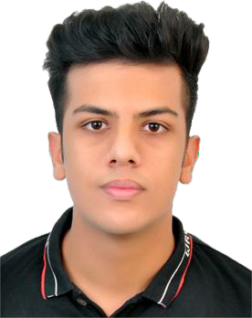
Profile Statement

Name: Vansh Gupta

Position: Vice President Internal & External

I’m Vansh Gupta, a third-year Business Management Co-op student at Langara. I have worked with the Academic Success Centre, volunteered over 160+ hours through programs
like Volt Go and Langara Global, and contributed to the Langara Students’ Union and student clubs. With a 3.74 CGPA and multiple Dean’s Honor Roll awards, I balance academics with
leadership and service. My focus has always been to help students succeed, feel supported, and build stronger connections on campus.

Platform Statement
Being at Langara for the past three years has given me a chance to see both the good parts of our campus and the areas where things can be improved. I’ve tried to do my part by working on projects that made student resources more accessible, helping bring more people to events, and volunteering to welcome new students and make them feel at home. Through leadership in clubs and being active in the Students’ Union, I’ve learned how much even small changes can help students feel more connected.
Now I want to take that to the next level. As Vice President Internal and External, my goal is to create events that truly bring students together, make sure concerns are not just heard but acted on, and push for stronger resources that support both academic success and student life. I know how to get things done because I’ve already done it on a smaller scale, and this role will give me the chance to do it for all students.
The steps I’ve taken so far were just the start. With your support and your vote, I’ll work to make Langara a place where every student feels included and proud to belong.

