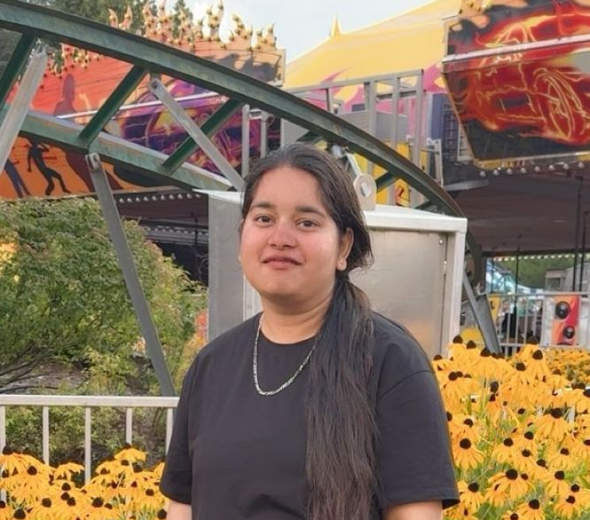
Name: Anjali Gaught
Position: International Student’s Representative

Profile Statement
I am a Langara student and returning International Students’ Representative who is passionate about supporting and connecting with students from around the world. Through my experience at Langara, I have gained a better understanding of the challenges international students may face and the importance of having someone they can approach and trust. I value communication, empathy, and student advocacy, and I want to continue using my experience to listen to international students, share their concerns, and help create a more welcoming and supportive Langara community.

Platform Statement
As a returning International Students’ Representative, I want to continue supporting international students and building on the experience I have gained through my time with LSU.
My focus will be on listening, connection, and support. I want international students to feel comfortable reaching out when they have questions or concerns about academics, finances, employment, campus resources, or adjusting to life in Canada.
I also want to create more opportunities for international and domestic students to connect through social activities, cultural events, workshops, and peer support. I believe these connections can make campus feel more welcoming and help students feel that they belong.
I will continue working with LSU, student groups, and campus services to share useful resources and bring international students’ concerns forward.
Most importantly, I want to remain an approachable and reliable voice for international students, someone who listens, understands their experiences, and works with them to make their time at Langara more supportive and connected.

