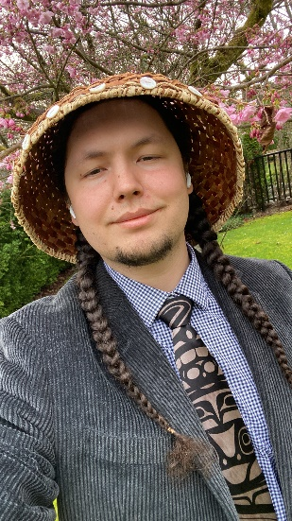
Name: Ashton Peterson
Position: Diversity & Inclusion Representative
Profile Statement
Hi, my name is Ashton Peterson. I’m an Indigenous student in the Nursing program at Langara College and previously served as the Indigenous Students’ Representative for the LSU. Building on that experience, I’m ready to hit the ground running by reviewing existing policies and opportunities that impact diverse students. I’ll work collaboratively with other elected representatives to advocate for meaningful policy improvements and, where appropriate, propose bylaw changes or reviews.
Platform Statement
The Diversity & Inclusion Representative has an important role in making sure every student feels seen, heard, and represented. At a time when conversations surrounding diversity and inclusion can be increasingly divisive, I believe our school should be a place where our differences are not overlooked, but celebrated.
I want to create opportunities for students to learn from one another through cultural events, workshops, and conversations that encourage understanding and connection across our diverse community.
As Diversity & Inclusion Representative, I will collaborate with established student organizations such as the Black Student Union, Punjabi Association, and other cultural and identity-based groups, to amplify their voices and ensure they have a meaningful voice at the table. Rather than speaking on behalf of these communities, I want to work alongside them to bring their ideas and perspectives into our school community.
Our differences are not barriers to overcome; they are opportunities to learn from one another. Together, we can celebrate what makes each of us unique, create space for every voice, and build a more connected and inclusive school community.

